DINOSAURIOS

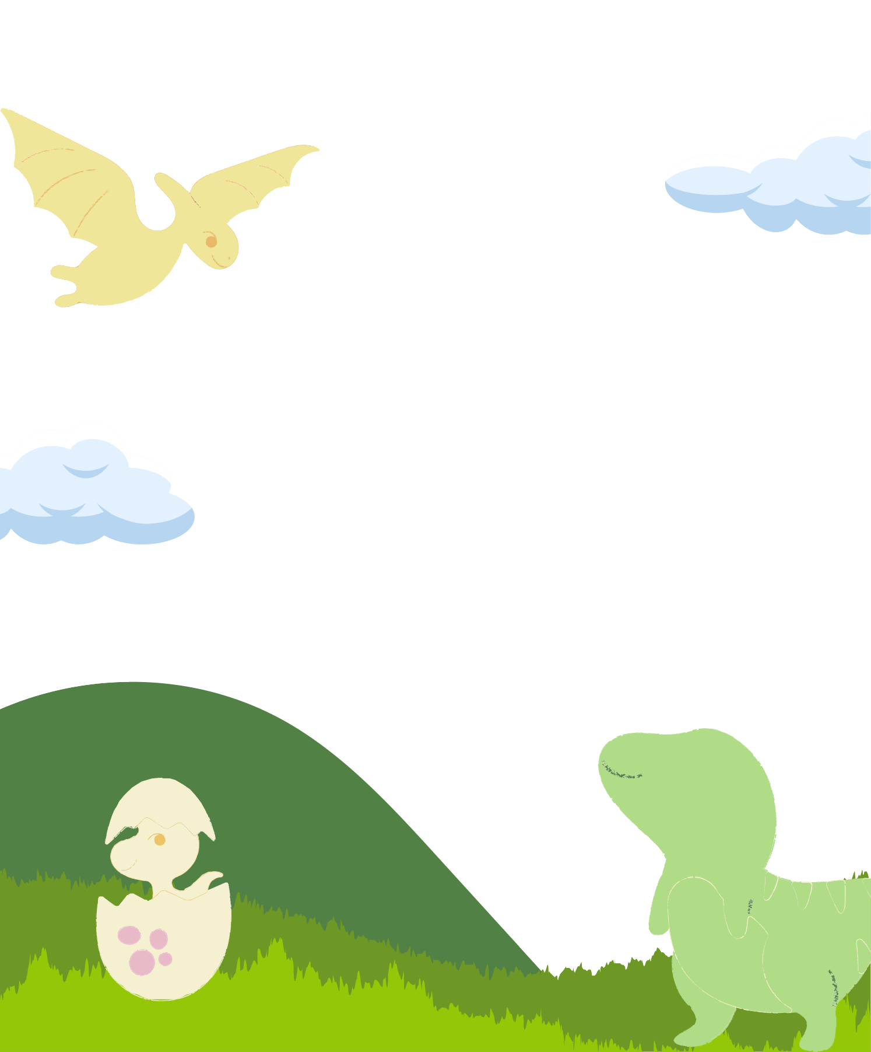

|  |  |  |  |  |
| --- | --- | --- | --- | --- |
| A S I G N A T | U | R | A | :: |
| P R O Y E | C | T | O | :: |
| N O M | B | R | E | :: |
| F E | C | H | A | :: |